http://localhost/php-crud-api/api.php/records/customers

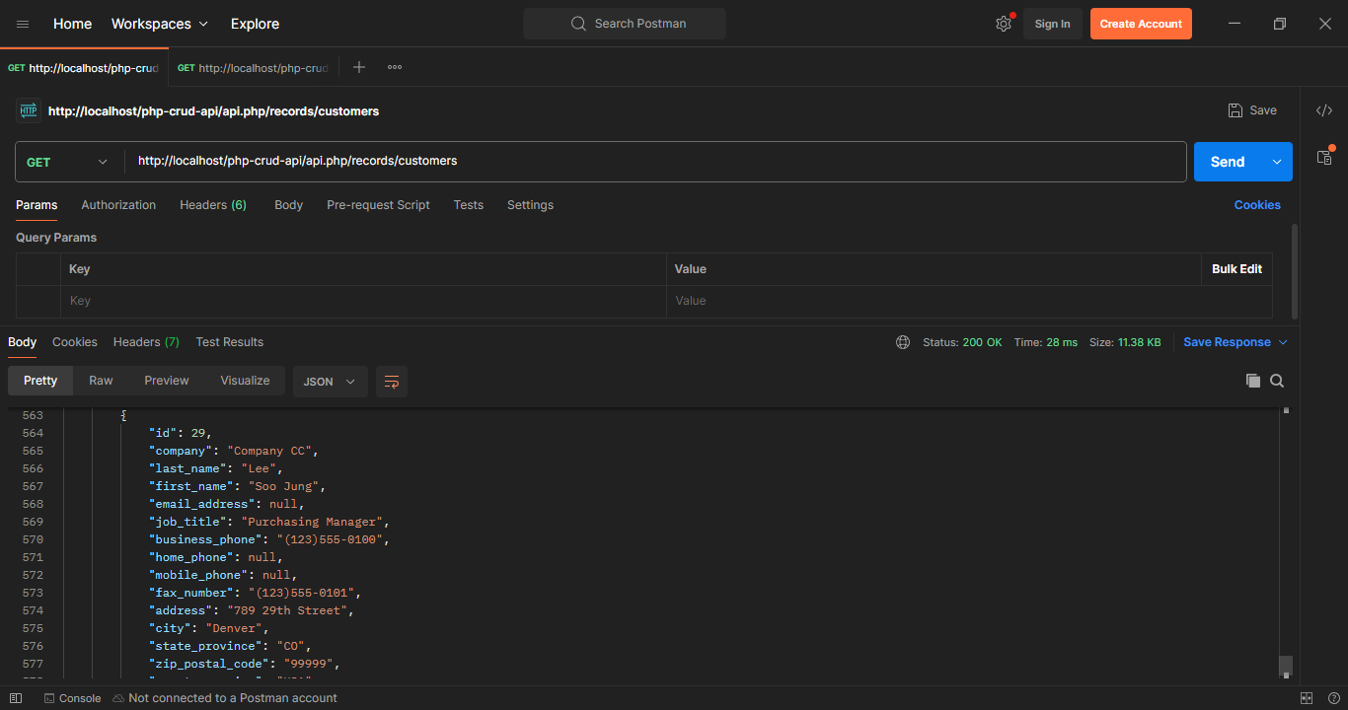

http://localhost/php-crud-api/api.php/records/customers/7

